**Examination System**

Developments Documentation

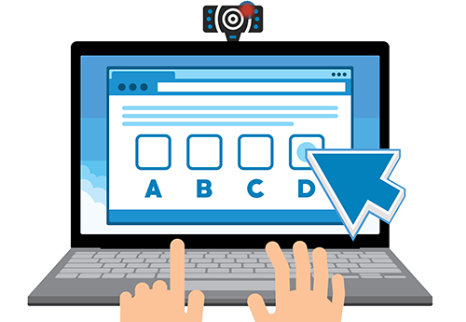

1. **Introduction**

Online Examination System is a software application, which allows a particular company or institute to arrange, conduct and manage any objective examination via online using modern technologies.

1. **Purpose:**

The purpose of this application is to conduct and process various types of certificate/non-certificate exams at different centers across any country via online.

1. **Features**:
2. User Managements
3. Role Managements
4. Exam Managements
5. Subject management
6. Question Managements
7. File Managements
8. Group Managements
9. Quiz Managements
10. Handling Cheating
11. Reporting and analysis
12. Chat messaging
13. Portal/BLOGGIN
14. Log in And Registration
15. Tracking
16. **Advantages**

* Today, most of the companies or institutes are conducting their exams online to be a part of this fastest growing world.
* Online Examination System covers almost all type of problems faced by a company or institute while conducting online examinations.
* User can give any available exam at any available center as per his/her choice.
* The results of the online exam will help a company or institute to list out the outstanding exam takers all over the country.



1. **Use Cases:**

* **System users /actors/:**
  + Super admin
  + Admin
  + Examination System
  + Students
  + Teachers

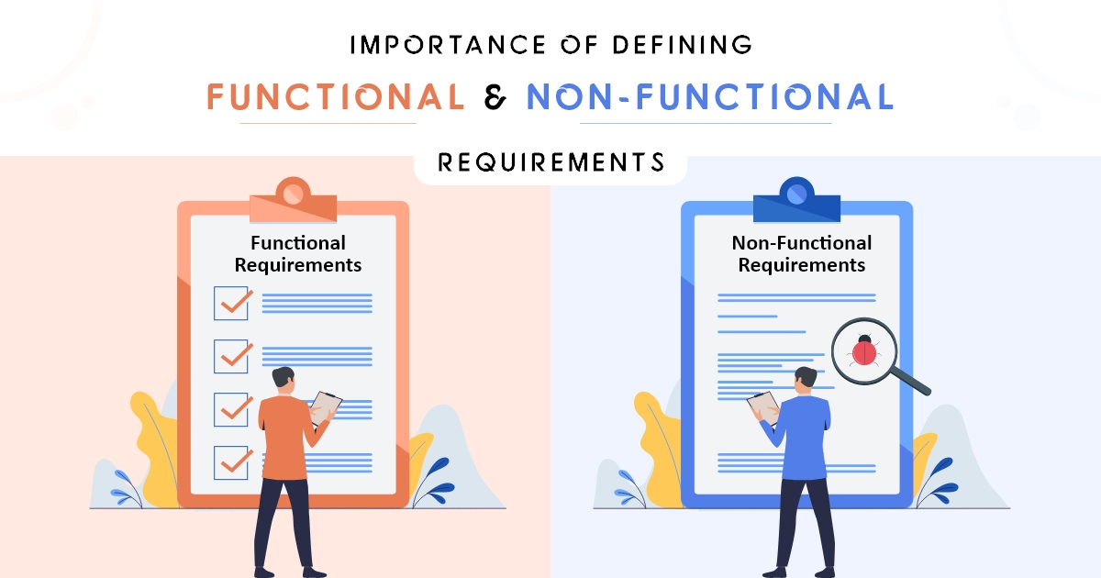

1. **Functional requirements:**

**1. Admin:**

* **Login to the system.**
* **Monitor system users:**
  + Track suspicious user acts.
* **Organize Teachers.**
  + - Create a new teacher
    - Edit teacher information
    - Delete teacher
    - Change teacher status
    - Teachers cannot access other subjects than their own.

*Notice: Teachers can Create Their own Subjects But only the system admin can change access permissions for other Teahers’ Subjects.*

*Teacher can send requests to join other teachers subjects and they gain access once the request accepted.*

* **Organize Students.**
  + - Create a new student
    - Edit student information
    - Delete student
    - Change student status
* **Organize roles.**
  + - Modify permissions for the actor of the system
      * Make a teacher function as a student at the same time
* **Check stored data.**
  + - Checking the statistics in details later.
* **Access to Dashboard:**
* Check Development Database
* Check Technical Support Features
* System Success/Failure Chart (Uptime- Downtime)
* **Survey Managements:**
  + Create Surveys:
    - Questions Topics
      * Personal Questions
      * General Feed Back
      * Question Specific
      * Experience
    - Question Types
      * Choose One Answers
      * Choose Multiple Answers
      * Free Text Questions
  + Modify Surveys
  + Delete Surveys
* **Super sets of all teacher privileges.**
* **Super sets of all Student privileges.**
* **Super sets of all Security privileges.**

1. **Graphical User Interface for the Amin:**
   1. Create New User GUI:

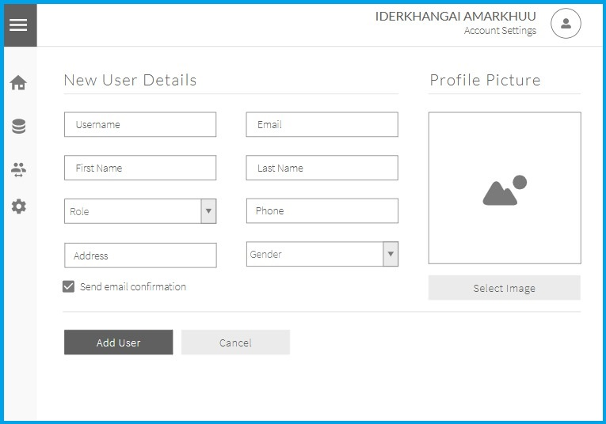

Create New User GUI

* 1. Create New User GUI:

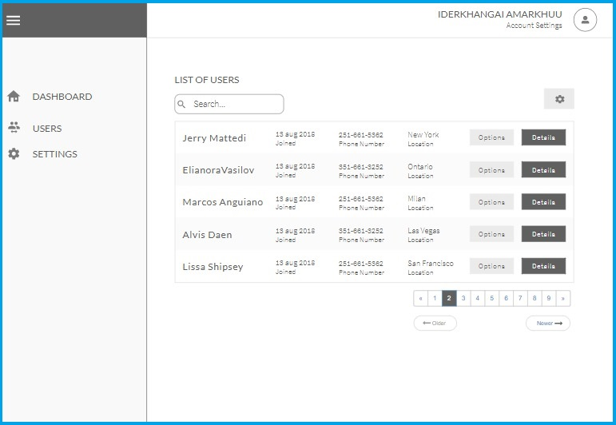

Show List of User GUI

* 1. Create New User GUI:

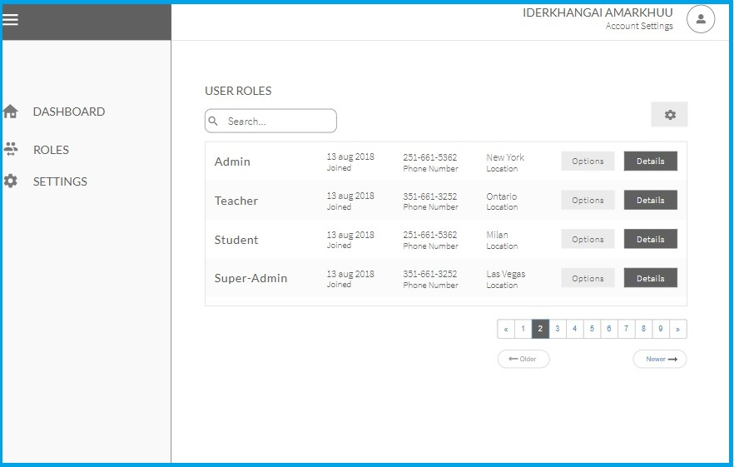

Customize Users Roles

1. **Examination System: (Automated Functions)**

* **User Validation:**
* **Validate system users:**
  + **Registration Validation:**
    - Email Verifications
    - Phone Number Verifications
  + **Exam Validation:**
    - ID Verification (before exams)
    - Face Recognition System
    - Eye Ball Tracking
* **Generate Questions:**
  + Randomly choose a number of questions from the pool.
  + Parameters Check for Questions Generation
    - Exam Form Type
    - Exam Grading Options
    - Exam Pictures
    - Questions Difficulty
    - Questions Topics Relations
    - **Notice: Generating of Questions is based on Certain Criteria like:**
    - Covering all topics, Increased Difficulty on exams, Mixed Questions Form Types, Add one Pictures, Automated oral Exams.
* **Generate Reports.**
  + Grade Lists
  + Fail/Success Statistics
  + Appliance Statistics
  + Student Specific Statistics
  + Subject Specific Statistics
* **Deliver (Forward) Surveys to students after Exams**
* **Handling Data (Teachers , Students)** 
  + Messaging Information
  + Encrypted Exam Data Transfer
  + Timers for Exams
  + Tracking:
    - Recording Student Interactions During Exams
    - Live Camera Streaming Video and Audio
    - Tab Monitoring
    - Block Clipboard and Right Click.
    - Image Save Blocked
* **Send Notifications (System/Email/SMS)**
  + Shared Notifications Topics
    - Examination Schedules
      * On Registration
      * Reminder one day before Exam
    - Subject Registration
    - Examination Results ( Student Specific , Teachers gets all students Results)
  + Teacher Notifications:
    - Student Registrations for owned subjects
    - Student Exam Attendance for owned subjects
    - Student Messages (Limitation it is monitored by the system Administers)
    - Other Teachers Requests and Questions
    - Groups notification
  + Student Notifications:
    - Teacher Messages
    - General Messages from the System
    - Student Certification Results
    - Future offers.
* **Handle Securities**
  + Details to be specified here.

1. **Teachers :**

* **Log in to system**
* **Organize Students.**
* **Organize Exams**
* Create a new exam Questions
* Edit exams Questions
* Delete exams
* Change student status

**Notice** : (Limitation is not less than 200 questions)

* **Organize Question**
* Create a new questions for exam
* Edit questions
* Delete questions
* Change question status
* **Organize quiz**
* Create a new quiz
* Edit quiz
* Delete quiz
* Change quiz status (active, inactive)
* **Organize Groups**
* Create a new groups
* Edit quiz
* Delete quiz
* Change quiz status (active, inactive)
* **Organize Subjects**
* Create a new subject
* Edit subject
* Delete subject
* Change subject status
* **Manage Reports**
* Create a report
* Edit report
* Delete report
* **Chat Messaging**
* Message to students
* Delete text message
* Receive the message from students
* **Blog and Post**.
* Create a new post
* Post only for specific groups
* Post blog for specific subjects
* Edit post
* Delete post
* **Handling Cheating**
  + Activity Tracking
    - Blocking Copy Paste
    - Browser tab switch tracking
  + Web Cam Tracking
  + Audio Tracking
  + Screen Sharing and Recording

1. **Students:**

* Search exam and quiz
* Browse subjects
* Take an exam.
* Going Forward-Backward during Exam
* Message Teachers
* View posts
* Preview Your Exam
* See exam Results
* Take a quiz
* See quiz result
* See exam and quiz reports

**Non-functional requirements**

1. **Reliability**

The system can update its content in real time. Therefore, changes such as addition,

Deletion or modification can be done immediately. This ensures that the content of the

System is up-to-date, reliable and can be trusted. The system will also be able to produce all related output to queries.

1. **Availability**

The system can operate 24 hours per week and 365 days a year. As long as the user not shut down the desktop. All the information will be keep in the database. Even though, the desktop is shut off information still exist in the database.

1. **Efficiency**

System should be efficient enough to meet all kinds of requirements as required by the lecturers and students. The system should not hang or lose its efficiency in any kind of worse conditions. It should provide the correct output in all manners.

1. **Flexibility**

System is working easily on the Intranet with the username and password of the user. The system has given the rights to the lecturers and the students to use the system with their username. The system can also work on other kind of technology with the little modification. System should be quite flexible to install and maintain

1. **Performance**

* The database shall be able to accommodate a minimum of 10,000 records of students.
* The software shall support use of multiple users at a time.
* There are no other specific performance requirements that will affect development.
* Server responding time must be lesser than 4.
* Web app should reliable to all browsers

1. **Security and Safety** 
   1. The database may get crashed at any certain time due to virus or operating system failure. Therefore, it is required to create backups of data
   2. Assign certain features to different modules and users
   3. Restrict communication between students
   4. Encrypt data and authentications process must be done
2. **Interface requirement**

The user interface should be designed to make the user’s work easier and more effective and the principles for good interface design include concern for content and context for navigation through activities, aesthetic consideration, assistance for novices and experts, consistency, and minimizing user effort.

* Interface should be easy to follow, user friendly
* It should not have many graphics which bothers eyesight
* It should not have hidden elements and components
* It should always produce relevant error and warning messages

**Software quality attributes**

The Quality of the System is maintained in such a way so that it can be very user friendly to all the users.

The software quality attributes are assumed as under:

* Accurate and hence reliable.
* Secured.
* Fast speed.
* Compatibility.

**System Interfaces:**

This section describes how the software interfaces with other software products or users for input or output.

6.3.1) **User Interface**

Application will be accessed through a Browser Interface. The interface would be viewed best using 1924 x 1268 and 800 x 600 pixels resolution settings.

The software would be fully compatible with common browsers.

No user would be able to access any part of the application without logging on to the system.

6.3.2) **Hardware Interfaces**

**Server Side:**

* Operating System: Windows 10 or Linux, Unix
* Processor: Intel Core i7 10th gen or higher
* CPU: 2.60hz or higher
* RAM: 16GB or more
* Hard Drive: 500 GB or more

**Client side:**

**Recommended:**

* Operating System: windows 10 or Linux, Unix
* Processor: Intel Core i7 10th gen or higher
* RAM: 16GB or more

**Minimum:**

* Operating System: windows 10 or Linux, UNIX.
* Processor: Intel Core 2 duo.
* RAM: 4GB or more.

**Software Interfaces**

* Client Side:.HTML, Javascript, Web Browser, Windows 10
* Web Server:.HTML, Javascript , windows 10

**Database design**

The database is used for the purpose of handling information as an integrated whole. It is defined as a collection of interrelated data stored with less or no redundancy to serve many users quickly and effectively. We should design a database to see how data should be organized around user requirements. The objective of the database is to make information access, easy quick, inexpensive and flexible for other users.

**During database design the following objectives are concerned:**

➢ Controlled Redundancy

➢ Data independence

➢ Accurate and integrating

➢ More information at low cost

➢ Recovery from failure

➢ Privacy and security

➢ Performance

**Use Case Diagram:**

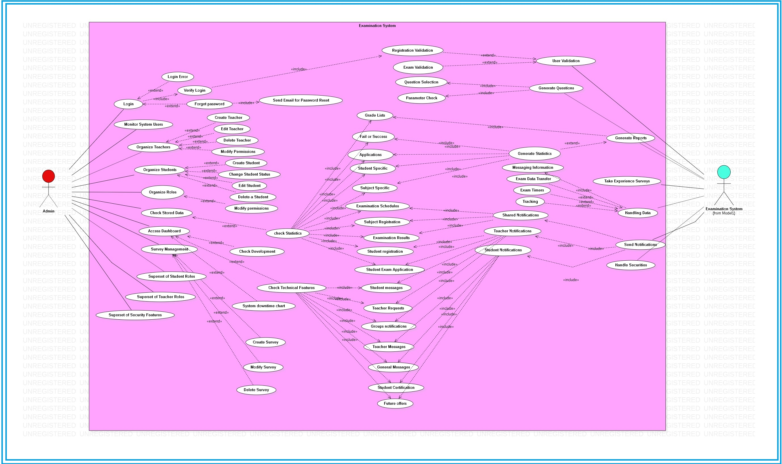

* + - Use Cases Diagram

**Dataflow Diagram:**

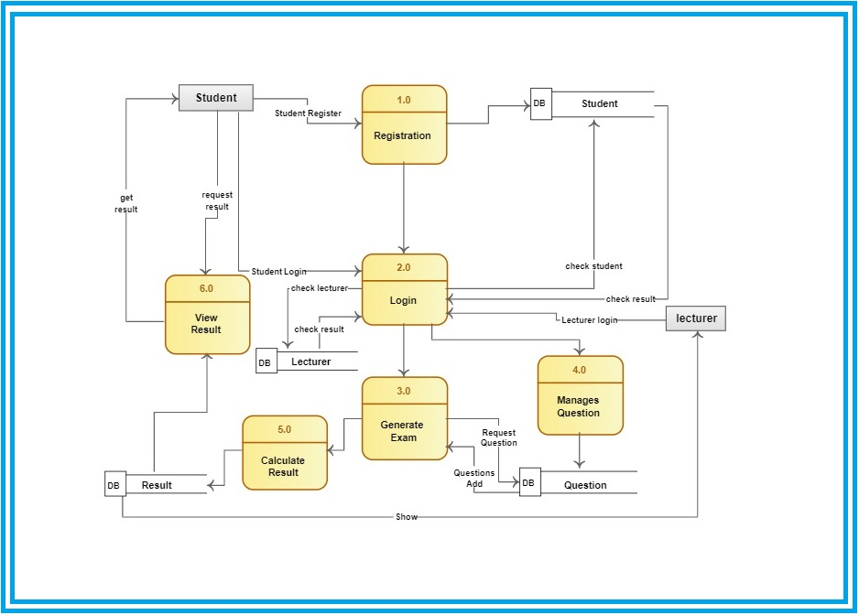

* + - Data Flow Diagram

**Sequence Diagrams:**

